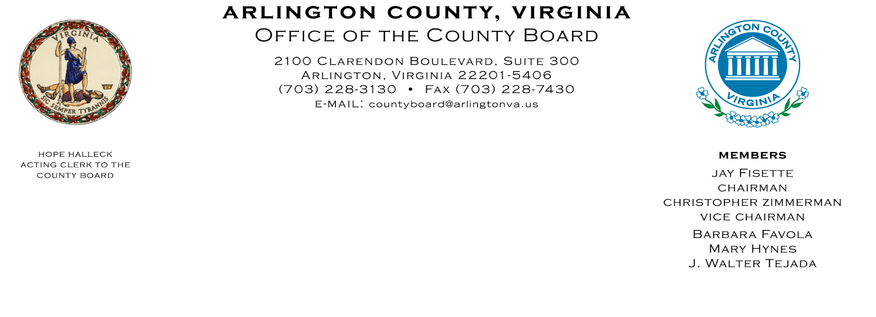

Members

Jay Fisette

Chair

Katie Cristol

Vice Chair

Christian Dorsey

Libby Garvey

John Vihstadt

February 13, 2017

Mr. Daniel Manzoni, Coordinator

Argentina National Day Celebration Committee

Arlington, Virginia

Dear Mr. Manzoni,

I am writing to congratulate the Argentina National Day Celebration Committee as an important milestone approaches. While you plan the 30th anniversary of this festivity in Arlington on May 13, 2017, we are honored to be the home of such fun and exciting tradition. It is this type of celebration that exemplifies the County’s vision of a diverse and inclusive community in which each person is important.

You can be proud of the rich history of Argentineans, celebrated annually in Arlington. The County Board, staff, and Arlington residents continue to recognize the many significant contributions that Argentineans bring to the Arlington community. Board members have attended prior celebrations and have always enjoyed it.

We know that the festivities, including an Exhibition of the History of the Festival in the Embassy of Argentina on May 12th and the 30th Argentina National Day Celebration the next day, will be a very special tribute, as well as a great celebration, that will be remembered for years to come as they coincide with the Year of Argentina’s Celebration of the May Revolution of 1810.

The County enthusiastically anticipates participating in the festivities being planned for the celebration of Argentina National Day in Arlington County.

Best wishes for another successful event this year.

Sincerely,

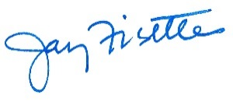

Jay Fisette,

Chair, Arlington County Board